Ex.No. : 3
Date:

Aim:

DML Commands – INSERT, SELECT

To perform Data Manipulation Language (DML) Commands such as INSERT, SELECT in the table.

Description:

Data Manipulation Language (DML) statements are used for managing data within schema objects. DML Commands: Insert, Select
- INSERT - insert data into a table
- SELECT - retrieve data from the a database

INSERT:
INSERT INTO table_name VALUES (value1, value2, value3,...); ( or )
INSERT INTO table_name (column1, column2, column3,...) VALUES (value1, value2, value3,...);

SELECT:
SELECT column_name(s) FROM table_name;

Questions:
- Populate all the five tables with your own data.
- View all the records from the five tables.

OUTPUTS:
1)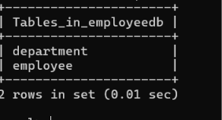

2)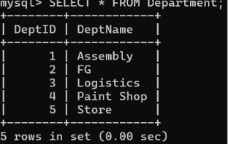

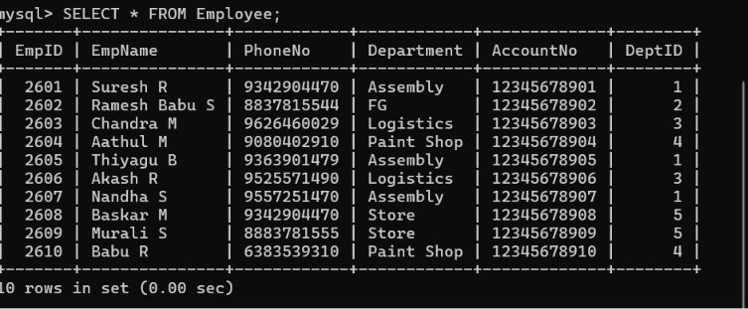

RESULT:
Data Manipulation Language (DML) Commands such as INSERT, SELECT are performed in the five tables.

